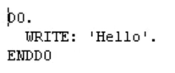

one thing you might notice, is that there's nothing telling this loop statement, when to stop.

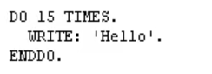



Well, we need to add some mechanism to this Do loop, to tell it when to stop processing the block of code, in-between the Do and End Do statements. And that's where we introduce the times addition.

Do loop actually uses an internal counter, to control how many times the loop is executed. You can check the SY-index system variable, to see how many times your loop has been processed.